‘FRESH PERSPECTIVES ON PILGRIMAGE AND PLACE’

18th - 19th July, 2017
The Treehouse, Berrick Saul Building, University of York

Project Background
In autumn 2017 an interdisciplinary team (History, Social Anthropology, Religious Studies, Theology, Archaeology, Art History and 3D visualisation) from the University of York, Open University and University of Toronto will complete a 3 year Arts and Humanities Research Council funded project on ‘Pilgrimage and England’s Cathedrals, Past and Present’. The project focuses on cathedrals as unique ‘laboratories’ in which to examine wider questions about the meanings and experience of pilgrimage and sacred space through the centuries.

The Conference
This free* two-day conference is designed as an opportunity to share project research outcomes in conversation with others working in the fields of pilgrimage and both journey- and place-related spirituality. To register your attendance, please complete and return the form below.
* Conference registration is free, with lunch and refreshments provided free of charge for both days. An optional evening meal at the University of York is being arranged for the Tuesday 18th, costing £15.00 per person. Details on how to book and pay for this meal are provided below.

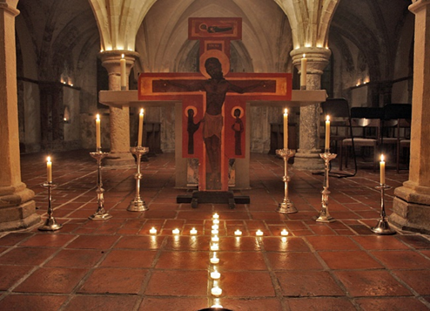
Rochester Cathedral

‘FRESH PERSPECTIVES ON PILGRIMAGE AND PLACE’

18th - 19th July, 2017
The Treehouse, Berrick Saul Building, University of York

Conference Registration Form

Title
Name
Affiliation
Email
Phone
Address
Dietary Requirements

Please return completed forms to candc-admin@york.ac.uk

Conference Dinner
Conference registration is free, with lunch and refreshments provided free of charge for both days. We are, however, arranging an optional evening meal at the University on Tuesday 18th at 18:00. The dinner costs £15.00, for two courses (with vegetarian options), tea/coffee and fruit juice.
If you would like to join us for the conference dinner, please book in advance via the University of York online store http://store.york.ac.uk/browse/extra_info.asp?compid=1&modid=1&prodid=2700

Travel and Accommodation
York is well served by rail and public transport. The University is located in Heslington, close to the city, and has a regular bus service between the campus and the railway station. When making travel plans, please note that the conference begins at 10:30 July 18th, and ends at 16:30 July 19th.
The University of York offers accommodation on campus near the conference venue, subject to availability. For details and options, please visit York Conferences. Alternatively, you may wish to stay in the city; please see Visit York for more information.

